Public transportation

Objectives:

Smart connected public transportation systems will offer many benefits to passengers. This technology will further improve the passenger's experience on public transit by offering real-time vehicle tracking, notifications in case of an unexpected event, and personalized travel news to passengers

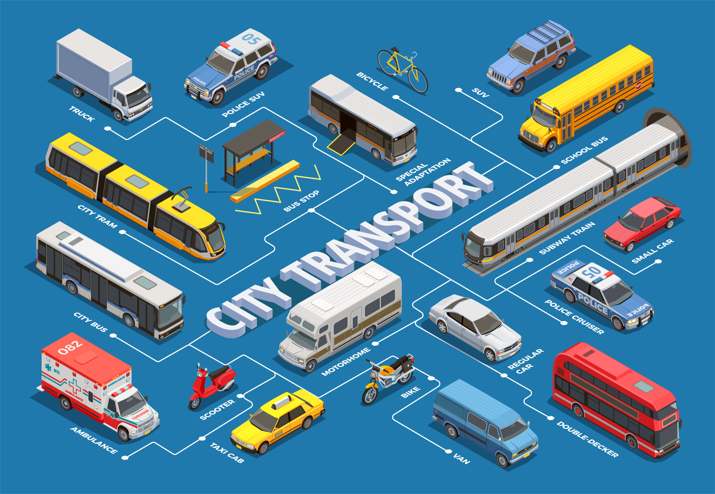

Luckily, the Internet of Things technology allows districts to easily track the location of their vehicles. Districts can install GPS systems on their vehicles that are connected to the internet. The GPS data is transmitted back to a central command center. Once the GPS data is received by central command, the information can then be relayed to the passenger’s internet-enabled mobile device or to an electronincs sign at transit stops.

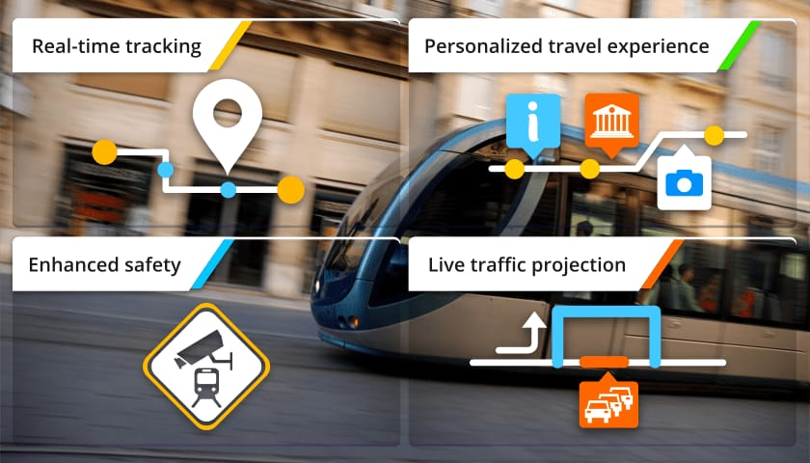

Unexpected Events

Unforeseen circumstances can sometimes disrupt public transportation such as breakdowns, road closures, or inclement weather. Internet of Things will enable districts to more easily re-route vehicles, notify passengers, and help them make alternate arrangements. In the event of an unforeseen circumstance, transit agencies will be able to notify passengers ahead of time by sending out alerts to their mobile phones instead of leaving passengers in the dark. IoT technology will also better enable transit agencies to develop a contingency plan in the event of an unforeseen circumstance.

Personalized Travel Information

People love to feel special. Personalized information will make passengers of public transport feel as if they are being taken care of. Internet of Things technology will enable transit agencies to easily send out personalized travel information to passengers. For example, transit agencies can track a particular person’s travel habits and determine which station and/or route that person frequently uses. In the event of a scheduled station closure or the re-routing of a particular route, the transit agency would be able to notify the person ahead of time

Block diagram

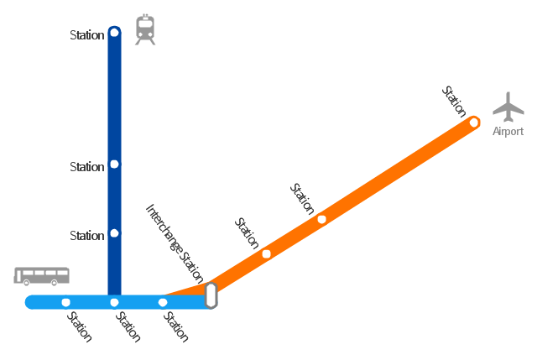

Innovative Ideas:

* ROUTING AND DISPATCH
* VECHICLE ENGINE MONITERING
* REAL-TIME SECURITY CAMERAS
* PASSENGER Wi-Fi
* DIGITAL SIGNAGE

Nowadays, the operating scales of the public transport providers can hardly meet the market demand because of the fast expanding volume of intercity passengers, the laggard bus dispatches and proper route management systems. From the societal perspective, this paper, under the framework of a public transit network with bus service providers and users, presents an integrated busses network management system with poles apart intrusion detection system (IDs) using satellite-based technologies applied.

an IoT based remote monitoring system which helps in providing real time information regarding bus timings and seat availability to the traveler's mobile app which ensures proper resource and time management. The IoT based system provides real time information regarding the bus location periodically through GPS module and its seat availability is sensed by a group of IR sensors as the bus crosses every terminal.

The core software designed is to provide the passengers to observe the approximate location of their desired buses, which also requires customizing hardware at every bus station found at the particular routes and reporting stations.

Passanger wi-fi

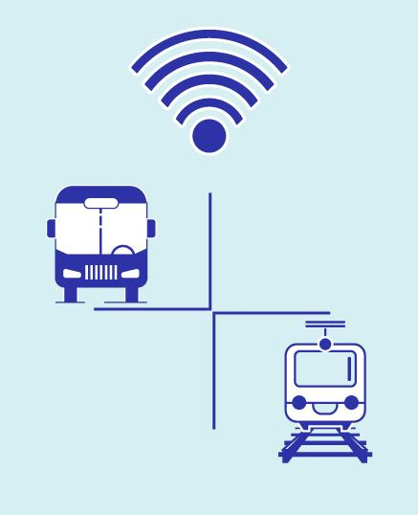

* Monitor the length of the commute to adjust fares accordingly.
* Ask for feedback on the quality of commute when passengers log in.

Direct commuters to the ticket purchasing website after logging to the WiFi.